# **Practical Exercises: Creating a Custom Policy**

Training Objective

Learn how to add a custom policy for the messages in the API Gateway by extending its request/response or fault flow.

Business Scenario

PizzaShack needs to have a log message every time an API is invoked.

High-Level Steps

* Create a common policy

Detailed Instructions

Follow the steps to add a custom common policy.

## **Creating a Common Policy**

A common policy is a globally maintained policy and you can easily utilize this policy at the operation level of any desired API. Note that these policies are not bound to any API and they are merely templates that you can easily use. Now let’s see how you can create such a policy. Follow the instructions below to create a new common policy.

1. Sign in to the WSO2 API Publisher.

https://<hostname>:9443/publisher

1. Navigate to **Policies** tab from the left menu and click **Add New Policy**.

[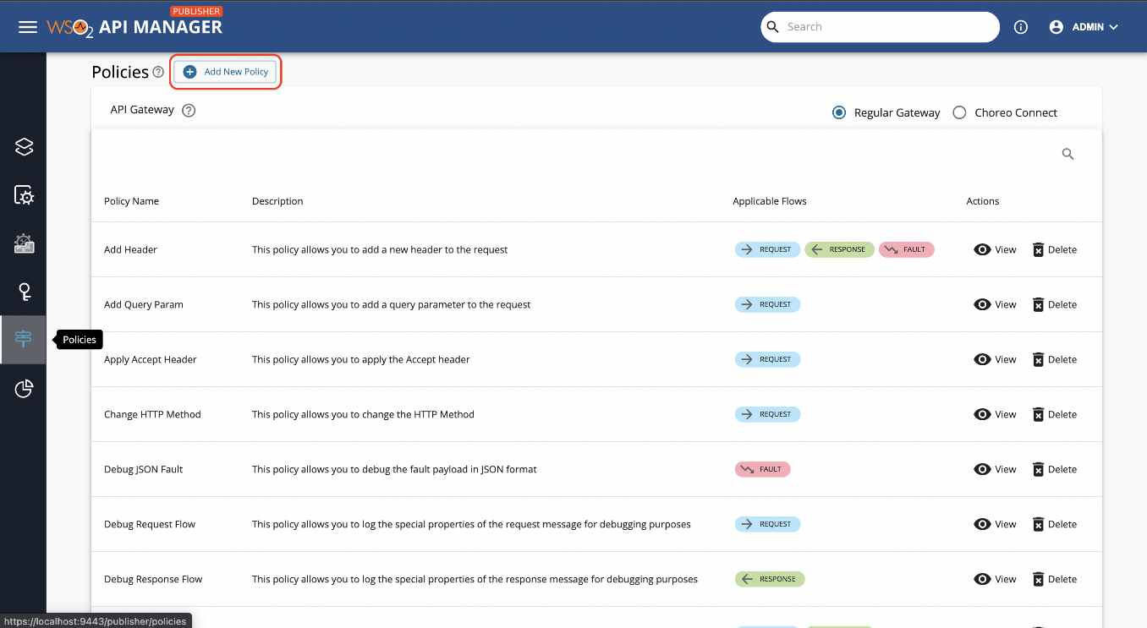](https://apim.docs.wso2.com/en/latest/assets/img/design/api-policies/common-policy-1.png)

**Note**

Common policy list will vary depending on the selected API Gateway.

1. Let’s create a policy named **Sample Add Header** for demo purposes. First let’s fill the **General Details** section using the following details.

[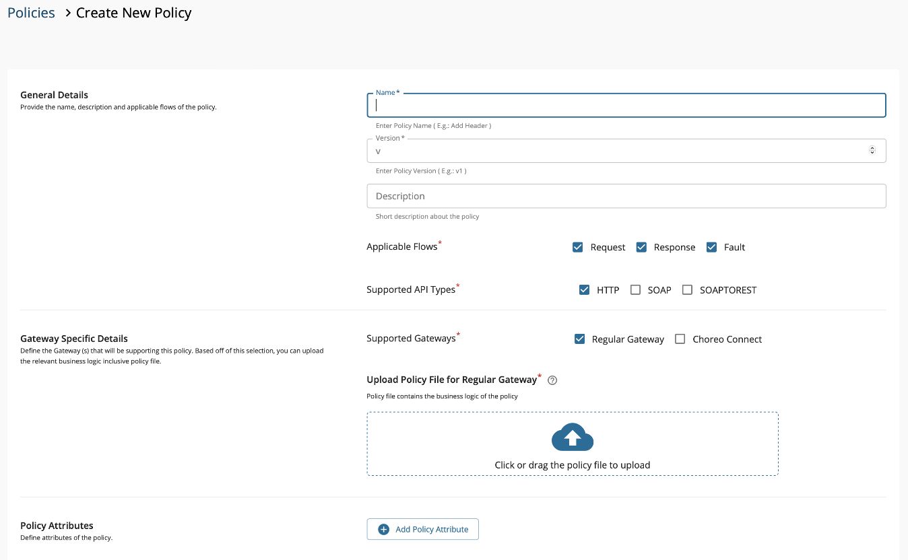](https://apim.docs.wso2.com/en/latest/assets/img/design/api-policies/common-policy-2.png)

|  |  |
| --- | --- |
| Field | Sample Value |
| Name | Sample Add Header |
| Description | Description of sample add header policy |
| Applicable Flows | Request, Response |

1. Next, we move on to the **Gateway Specific Details** section. This is where we upload the policy file that contains the business logic of the policy. The sample policy that we are creating here will be for the Regular Gateway (Synapse Gateway), and hence, the policy should be a .j2 or .xml file. Use the table provided below to fill this section of the form.

|  |  |
| --- | --- |
| Field | Sample Value |
| Supported Gateways | Regular Gateway |
| Upload Policy File | Copy the below content to a file named sampleAddHeader.j2 and upload.  <property action="set" name="{{headerName}}" **value**="{{headerValue}}" scope="transport" /> |

[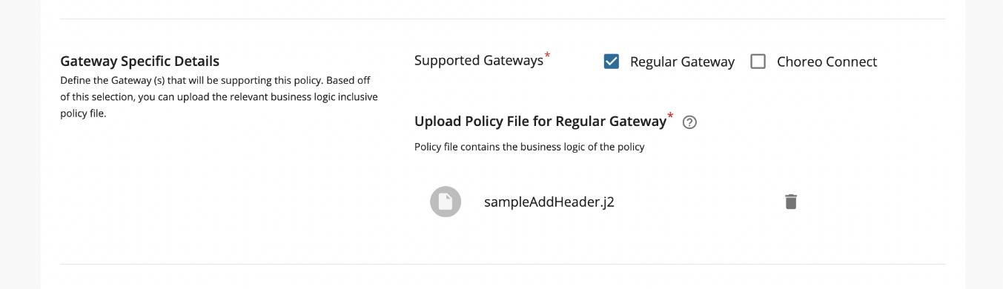](https://apim.docs.wso2.com/en/latest/assets/img/design/api-policies/common-policy-3.png)

**Note**

1. Please note that the policy content should not contain any XML – Prolog components. E.g.,: Should not begin with <?xml version="1.0" encoding="UTF-8" standalone="yes" ?>. You have to start from a root element or child elements.
2. The final section in the form is the **Policy Attributes** section. These attributes are derived from the policy file that you uploaded in the previous step. If you observe the policy content you should notice two dynamic values embedded into that policy, namely the headerName and headerValue. Those are the attributes that we should include when creating our policy (note that you can have a static policy with no attributes if the policy content is static). Let’s fill the **Policy Attributes** section using the following details.

[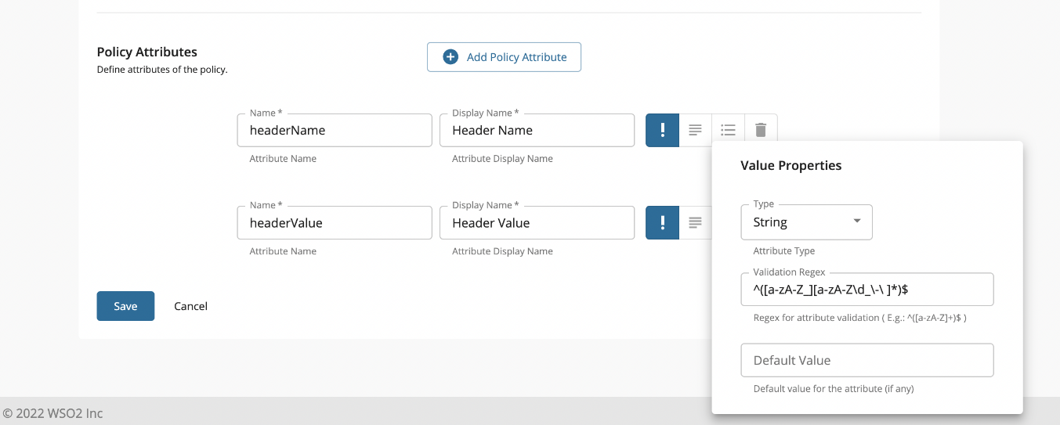](https://apim.docs.wso2.com/en/latest/assets/img/design/api-policies/common-policy-4.png)

**Attribute 1**

|  |  |
| --- | --- |
| Field | Sample Value |
| Name | headerName |
| Display Name | Header Name |
| Required | True |
| Description | Name of the header to be added |
| Type | String |
| Validation Regex | ^([a-zA-Z_][a-zA-Z\d_\-\ ]*)$ |
| Default Value | Leave this blank |

**Attribute 2**

|  |  |
| --- | --- |
| Field | Sample Value |
| Name | headerValue |
| Display Name | Header Value |
| Required | True |
| Description | Value of the header |
| Type | String |
| Validation Regex | ^([a-zA-Z\d_][a-zA-Z\d_\-\ ]*)$ |
| Default Value | Leave this blank |

1. Once that is done, the completed form should look like the below screenshot. We can now click on **Save**.

[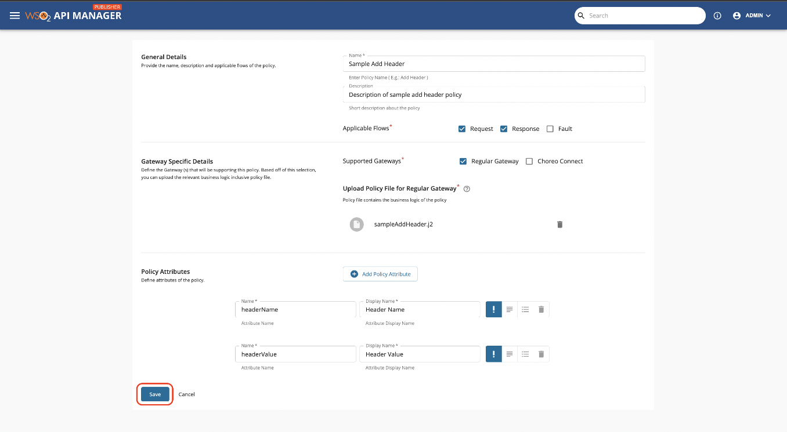](https://apim.docs.wso2.com/en/latest/assets/img/design/api-policies/common-policy-5.png)

1. Now the newly created policy will appear in the table. You can go ahead and search for this policy to verify.
2. Try viewing this policy by clicking on **View** action. Note that you can download the policy as a .zip file using the **Download Policy** button.

[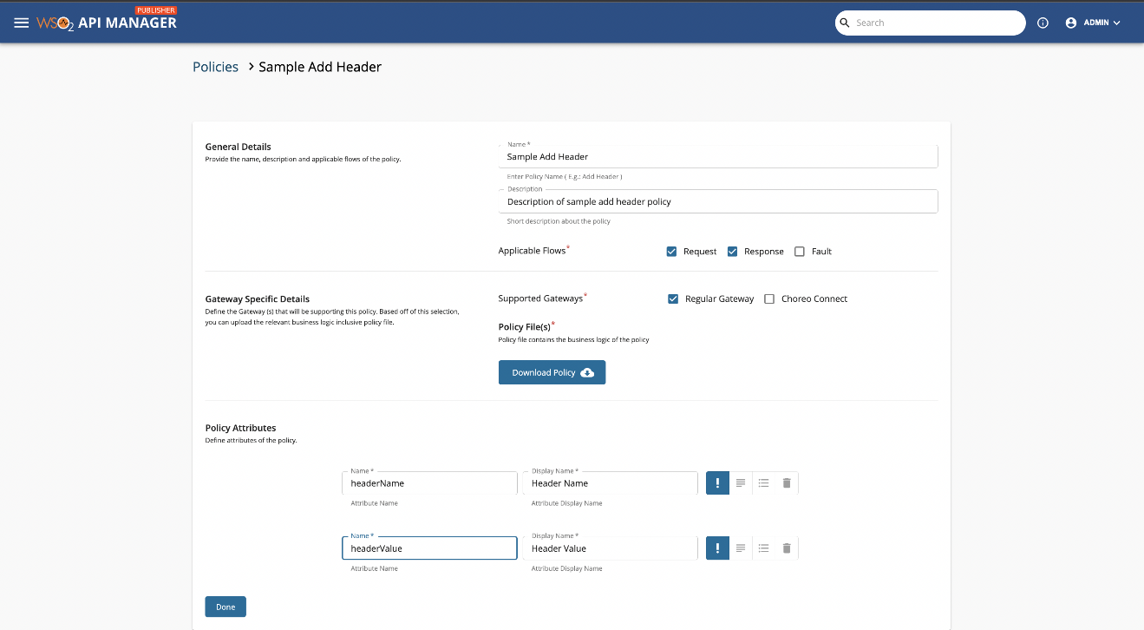](https://apim.docs.wso2.com/en/latest/assets/img/design/api-policies/common-policy-6.png)

Expected Outcome

As a result of the common policy created in this exercise, a log message is created every time an API is invoked.